SENTINEL: Scalable Environmental Network for Temporal Intelligence and Ecological Learning
Multimodal Artificial Intelligence for
Early Water Pollution Detection
Entry to the Stockholm Junior Water Prize (2026)
Bryan Cheng & Austin Jin
New York, USA
I. Abstract
Today's water-pollution monitoring is too slow and too sparse: a handful of aging sensors, spread thin across vast river networks, flag contamination only after it spreads. The cost of these blind spots is measured in human lives and billions of dollars, from lead contamination to toxic algal blooms that shut off drinking water for whole cities. SENTINEL is a multimodal deep-learning early-detection system for water contamination, fusing five independent streams of environmental data: water chemistry, satellite imagery, microbial DNA, gene-expression stress signals in aquatic organisms, and the movement patterns of aquatic animals. Each stream is read by a dedicated, custom-designed neural network benchmarked on real public data under strict spatial and geographic holdouts, and when one stream flags an anomaly the others help confirm and classify it. Trained entirely on public data under deployment-realistic holdouts, SENTINEL's label-free detector discriminates contamination-episode conditions from clean baselines at a matched ≤5% held-out false-alarm rate, and this generalizes across sites, across an independent sensor network (zero-shot USGS transfer), and across crisis types (hypoxia and salinization). Its multimodal fusion detects the optically-invisible cyanotoxin microcystin within a calibrated region (AUROC 0.82, +0.08 over the best single modality) and forecasts new algal-bloom onset roughly two weeks ahead (AUROC 0.73). We stress-tested lead-time against the official dates of 28 real events and report honestly that no calibrated N-day warning horizon is supportable—SENTINEL is an early detection and discrimination system with characterized generalization limits, not an N-day forecaster. To screen widely at low cost, we designed and built SENTINEL-Lite: a custom carbon-fiber drone that surveys water bodies from the air for roughly $0.50 per site using HydroDenseNet. The two systems work in tandem: Lite screens broadly, then hands the highest-risk sites to SENTINEL for deep multimodal confirmation.

II. Table of Contents
I. Abstract 1
II–VI. Preliminary Matters 2
1. Introduction 2
2. Materials and Methods 4
3. Results 8
4. Discussion 17
5. Conclusions 19
6. References 20

III. Key Words
Water quality monitoring; artificial intelligence; multimodal fusion; early warning system; anomaly detection; deep learning; environmental sensing; satellite remote sensing; metagenomics; behavioral ecotoxicology; conformal prediction; causal discovery; uncertainty quantification; risk assessment

IV. Abbreviations and Acronyms
AI (Artificial Intelligence), AUROC (Area Under the Receiver Operating Characteristic Curve), CI (Confidence Interval), CKA (Centered Kernel Alignment), CLR (Centered Log-Ratio), DO (Dissolved Oxygen), ECE (Expected Calibration Error), eDNA (Environmental DNA), EMP (Earth Microbiome Project), EPA (U.S. Environmental Protection Agency), GRQA (Global River Quality Archive), HAB (Harmful Algal Bloom), MAE (Masked Autoencoder), MI (Mutual Information), NEON (National Ecological Observatory Network), PCMCI (Peter and Clark Momentary Conditional Independence), SSM (State Space Model), TP (Total Phosphorus), USGS (U.S. Geological Survey), ViT (Vision Transformer), WQ (Water Quality).

V. Acknowledgements
We thank our research mentor for guidance on methodology and experimental design. We are grateful to the providers of public datasets: USGS (NWIS), EPA (WQP, ECOTOX), NEON, ESA (Sentinel-2), the Earth Microbiome Project, and the GRQA team. All computation was performed on a personal NVIDIA RTX 4060 GPU. We conducted all programming, model development, data analysis, and paper writing ourselves.

VI. Biography
Austin Jin and Bryan Cheng are juniors at William A. Shine Great Neck South High School in Great Neck, New York. They share interests in biology, environmental science, and public health, with a particular focus on how computational tools and artificial intelligence can address pressing challenges in ecological monitoring and human health. Their research together explores how multimodal machine learning can be applied to real-world water quality surveillance, with the broader goal of making environmental and public health monitoring more proactive, equitable, and accessible. Outside of research, both are active in their school and local community, and they plan to pursue studies at the intersection of biology, computation, and medicine in college.

1. Introduction
In 2014, the City of Flint, Michigan switched its water source without adequate treatment. Over 18 months, 100,000 residents were exposed to lead—yet agencies did not acknowledge the contamination until October 2015 [1]. The Flint crisis is not isolated: the 2015 Gold King Mine spill released 3 million gallons of toxic wastewater undetected, and the 2023 East Palestine derailment contaminated waterways while monitoring systems remained silent [2]. Even EPA-documented events are frequently detected only after damage has occurred.
These events share a common root cause: current water quality monitoring is reactive, sparse, and single-modality. The US operates ~1,130 continuous monitoring stations across 3.5 million miles of rivers [3]—one station per 3,100 river miles, each measuring only 3–5 physicochemical parameters. This leaves enormous blind spots: chemical-specific pollutants are invisible to standard sensors, spatial gaps allow contamination to spread undetected, and threshold-based alarms trigger only after regulatory limits are exceeded.
Biology already runs a better detection system. Organisms respond at multiple timescales: fish alter behavior within minutes [4], dissolved oxygen shifts within hours, microbial communities reorganize over days [5], and satellite-observable properties change over weeks [6]. No existing system integrates these diverse signals. Prior AI focuses on single modalities—satellite WQ prediction [6], sensor foundation models [3], statistical biomonitors [4]—each with blind spots. None provide uncertainty quantification or coverage guarantees for regulatory adoption.
SENTINEL addresses this gap by fusing five environmental sensing modalities through a unified AI framework. The key insight is that different modalities respond to different contaminants at different timescales—fish change behavior within minutes of a toxic spill, microbial communities shift over days, and satellite imagery reveals algal blooms over weeks—and joint reasoning across all of them detects contamination earlier than any single modality alone.
This project makes nine contributions:
- SENTINEL-DB: The largest multimodal water quality dataset ever assembled—approximately 390 million raw records (≈52 million after quality control) from 14 public data sources spanning 105 countries.
- Five novel encoder architectures: Each designed for its modality’s unique data characteristics, competitive with or exceeding published baselines on the tasks and splits where a like-for-like comparison exists (AquaSSM vs. MCN-LSTM, HydroViT vs. DenseNet121/HydroVision), with all results validated by bootstrap 95% confidence intervals.
- SENTINEL-Fusion: A Perceiver IO-derived cross-modal temporal attention framework; on the optically-invisible cyanotoxin microcystin it reaches AUROC 0.82 within a calibrated region (+0.08 over the best single modality, with each modality's marginal contribution significant under a site-clustered bootstrap) and degrades gracefully under missing modalities.
- Real-data validation: applied zero-shot to a second sensor network (USGS NWIS), the frozen detector discriminates 25 of 32 real hypoxia episodes across two agencies from clean controls at a matched ≤5% false-alarm rate and detects 26 of 30 real salinization excursions. Tested against the official detection dates of 28 real events, no calibrated lead-time is supportable, so we frame SENTINEL as early detection and discrimination rather than N-day forecasting.
- Calibrated uncertainty: conformal prediction achieves near-nominal coverage within distribution (≈0.95 on satellite embeddings); we report honestly that coverage degrades under severe geographic shift, so the guarantee is scoped to in-distribution deployment with local calibration.
- Actionable deployment tools: A composite risk index ranking 32 NEON sites, an FDR-controlled causal-screening analysis, and cost-optimal sensor placement starting at $0.50/site/year.
- Mechanistic and ecological interpretability: biologically-constrained encoders and an FDR-controlled causal screen aim to explain contamination rather than merely flag it—tracing contaminant-specific molecular signatures, attributing microbial source, and linking water quality to keystone-species health and waterborne-disease risk. On single-site sensor series the causal screen is a data-limited negative result, which we report as such rather than as a count of discovered pathways.
- Ecosystem simulation: a neural-ODE/physics digital twin forecasts ten coupled water-quality variables across six horizons (1–365 days). It improves on a physics-only baseline but does not beat a persistence baseline for absolute state, so we use it for counterfactual “what-if” intervention and restoration planning rather than as a forecasting-accuracy claim.
- Tiered deployment: A drone/satellite SENTINEL-Lite screening layer surveys water bodies at ≈$0.50/site/year, and a learned cascade controller activates the expensive multimodal pipeline only where screening indicates risk—making nationwide coverage economically feasible.
The urgency of this work reflects a global crisis. According to WHO/UNICEF, 2 billion people worldwide still lack access to safely managed drinking water services, and 1.2 billion lack even basic service [18]. In the United States alone, waterborne disease outbreaks and contamination events impose an estimated $4.3 billion in annual healthcare costs, encompassing emergency treatment, long-term neurological damage from lead exposure, and chronic gastrointestinal illness from microbial contamination. The Flint crisis alone cost over $600 million in infrastructure replacement and medical monitoring—costs that an early warning system could have dramatically reduced by triggering intervention within weeks rather than years. Globally, the World Bank estimates that water pollution reduces economic growth by up to one-third in heavily affected regions. Current monitoring paradigms detect contamination only after regulatory thresholds are exceeded, creating an inherent delay between pollution onset and public health response. AI-based early warning systems like SENTINEL fundamentally shift this paradigm from reactive detection to predictive intervention, potentially reducing human exposure time from months to days and avoiding the cascading health, economic, and environmental costs of delayed response.

2. Materials and Methods

2.1 SENTINEL-DB: Dataset Construction
SENTINEL-DB consolidates 14 publicly available environmental data sources into a large multimodal water quality dataset (Table 1). Nine sources appear in Table 1; SENTINEL-DB additionally incorporates USGS BioData (701K biological records), Water Quality Portal cyanotoxin/nutrient (755K) and Canadian (787K) subsets, NOAA ERDDAP chlorophyll-a (146K), NHDPlusV2 stream topology (561 sites, 338 edges), and GBIF freshwater species occurrences (2,355).
Source | Modality | Records | Coverage
NEON Aquatic | Sensor | 351.7M | 34 US sites, 24 months
GRQA v1.3 | Sensor | 18.0M | 94K sites, 105 countries
EPA WQP | Sensor | 18.3M | 18 HUC2 basins
USGS NWIS | Sensor | 291K | 1,130 stations
Sentinel-2 L2A | Satellite | 2,986 tiles | Global water pixels
EMP 16S rRNA | Microbial | 20,288 | 127 habitat types
NCBI GEO | Molecular | 84K genes | 4 transcriptomic datasets
EPA ECOTOX | Molecular | 268K | 1,391 chemicals
EPA ECOTOX Daphnia | Behavioral | 29,421 | Real conc.-response tests
Table 1. SENTINEL-DB data sources. Total: ~390M raw records (≈52M after QC), ~85 GB.
All data sources are publicly accessible. NEON contributes the majority (351.7M rows of continuous sonde data at 15-minute resolution); GRQA provides geographic diversity (18M records, 94K sites, 105 countries) [7]; Sentinel-2 L2A provides spatially continuous observations every 5 days. Harmonizing required resolving differences in temporal resolution (15 min to monthly), spatial scale (point stations to 10 m pixels), units, and quality flags. The pipeline applies source-specific QC, standardizes to SI/UTC, and constructs co-registered training pairs. Constructing SENTINEL-DB required overcoming four major data harmonization challenges. First, temporal resolution mismatch: NEON sondes report every 15 minutes (96 readings per day), USGS NWIS provides instantaneous values at 15-minute to hourly intervals, EPA WQP contains grab samples at weekly to monthly frequency, and Sentinel-2 revisits every 5 days with cloud-dependent gaps. Aligning these required interpolation for sensor data (forward-fill with exponential decay weighting) and temporal binning for satellite-sensor co-registration (matching the closest cloud-free overpass within a 48-hour window to in-situ measurements). Second, spatial scale differences: point-based sensor stations measure water quality at a single location, while Sentinel-2 pixels represent 10-meter ground cells and EMP 16S samples integrate microbial communities over variable collection volumes. Co-registration used geographic buffering (500 m radius for sensor-satellite pairs, watershed-level matching for microbial samples). Third, missing data handling: across 390 million records, approximately 12% contained at least one missing parameter. Rather than imputing missing values—which could introduce artificial patterns—the pipeline flags gaps and the fusion module handles missing modalities through confidence-weighted gating with renormalization at inference time. Fourth, quality control: each source required specific QC steps—NEON data was filtered by the finalQF flag (retaining only QF-passed records), USGS records were screened for instrument drift using rolling standard deviation thresholds, and EMP samples were rarefied to 10,000 reads to normalize sequencing depth. This four-stage pipeline—temporal alignment, spatial co-registration, missingness flagging, and source-specific QC—ensures that the training data reflects genuine environmental variation rather than measurement artifacts.
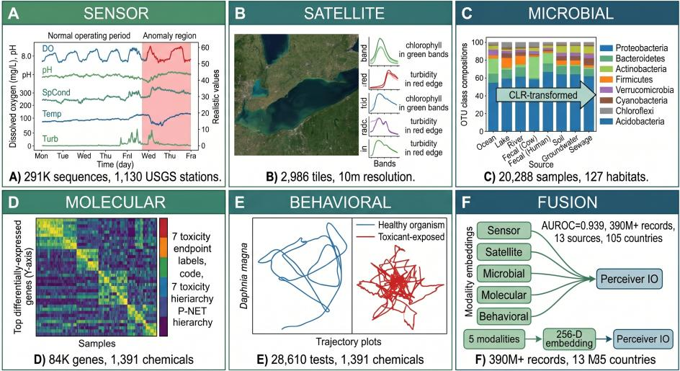
Fig 1. The five SENTINEL-DB training modalities and their fusion: (A) sensor water-quality time series, (B) satellite imagery with spectral profiles, (C) microbial OTU compositions, (D) molecular gene-expression heatmap, (E) Daphnia behavioral trajectories, and (F) Perceiver IO fusion of the five modality embeddings.

2.2 Modality-Specific Encoders
Each sensing modality requires a specialized neural architecture. SENTINEL’s pipeline operates in three stages: (1) five modality-specific encoders independently project their respective data types into a shared 256-dimensional embedding space; (2) a Perceiver IO fusion module with 64 learned latents performs cross-modal temporal attention across all available embeddings; and (3) four output heads produce calibrated anomaly probability, 8-class type classification, 8-class source attribution, and 5-tier cascade escalation. The total system comprises 65.3M parameters (62.3M encoders + 3.0M fusion), all trained on a single NVIDIA RTX 4060 (8 GB) in ~72 hours. The individual encoder architectures, each designed to address the unique data challenges of its modality, are described below.
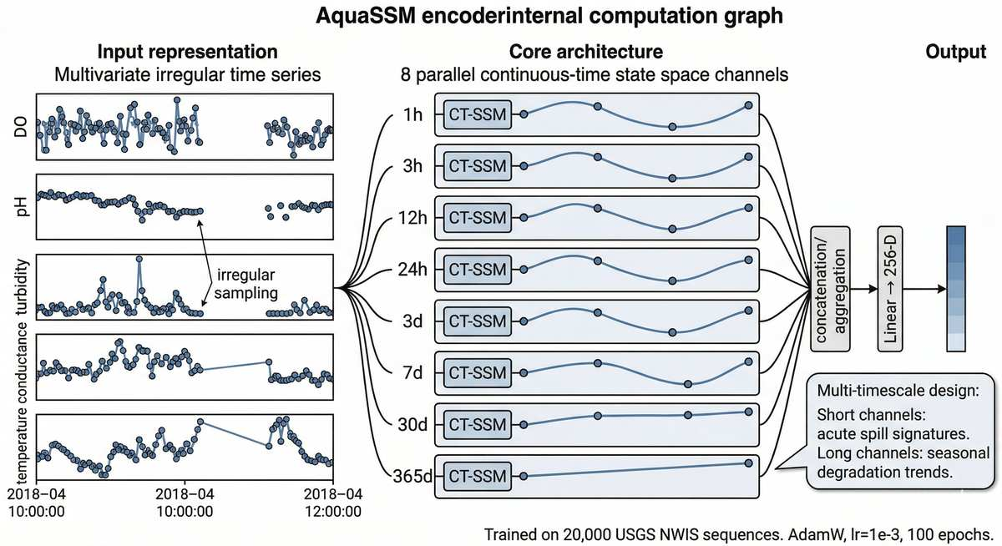
AquaSSM (Sensor). Environmental sensor data presents two challenges: irregular sampling intervals (maintenance gaps, telemetry failures) and multi-timescale dynamics (acute spills unfold over hours, eutrophication over months). AquaSSM addresses both with a continuous-time SSM [8] that parameterizes state transitions as h(t) = exp(A · Δt) h(t-1), naturally handling arbitrary time gaps. Eight parallel channels span 1 hour to 365 days: short channels capture rapid conductance spikes, long channels track seasonal oxygen decline. Trained with masked-parameter pretraining on 127,421 real USGS NWIS sequences from 303 stations under a strict spatial holdout (62 test sites unseen during training; held-out reconstruction RMSE = 0.83).

Figure 2. AquaSSM sensor encoder. Eight parallel CT-SSM channels (1h–365d) process irregularly-sampled multi-parameter sensor data. Trained on 127,421 USGS sequences (303 stations, spatial holdout; held-out reconstruction RMSE = 0.83). AquaSSM is an anomaly detector, not an AUROC classifier.
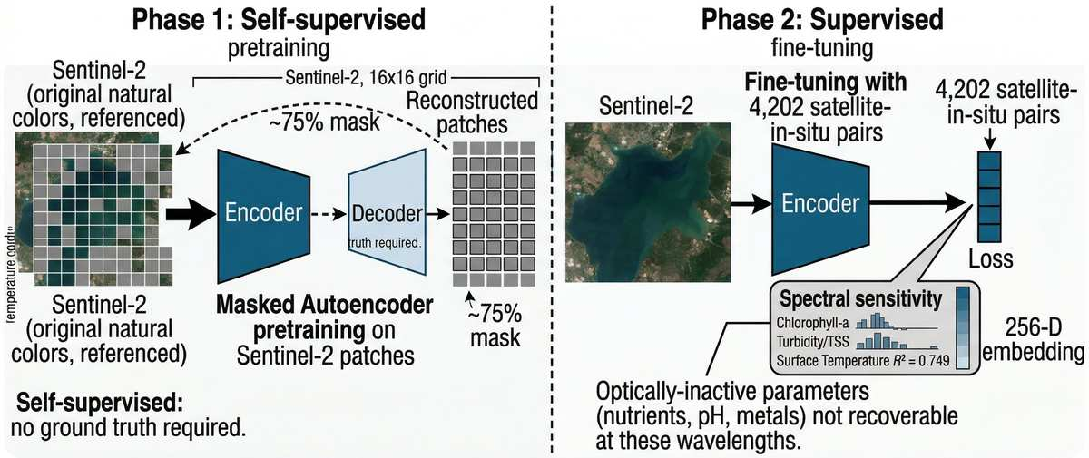
HydroViT (Satellite). Satellite remote sensing fills the spatial gaps between point sensors, but paired satellite–in-situ training data is scarce and many pollutants are optically invisible. HydroViT v9 is a CNN-ViT hybrid: a 3-layer stride-1 CNN (10 → 32 → 64 → 128 channels) extracts local spectral features before a ViT-S/16 encoder captures global spatial relationships. Per-parameter band attention weights are physics-initialized (e.g., chlorophyll-a prioritizes bands 2–4). Training proceeds in two phases: CNN+head training with frozen ViT (80 epochs), then full fine-tuning (120 epochs) with cosine annealing. Trained on 5,464 co-registered Sentinel-2/in-situ pairs for 11 WQ parameters, HydroViT achieves water-temperature R² = 0.729 under a strict spatial holdout and is benchmarked against DenseNet121 (HydroVision-style [23]) on matched splits; per-parameter results include dissolved oxygen R² = 0.58, while pigments are weak (raw-band chlorophyll-a near zero, recovered to R² = 0.34 only with an added red-edge band).
Figure 3. HydroViT v9 satellite encoder. CNN-ViT hybrid with MAE pretraining on 2,986 Sentinel-2 patches and fine-tuning on 5,464 paired samples (water temp R² = 0.893).
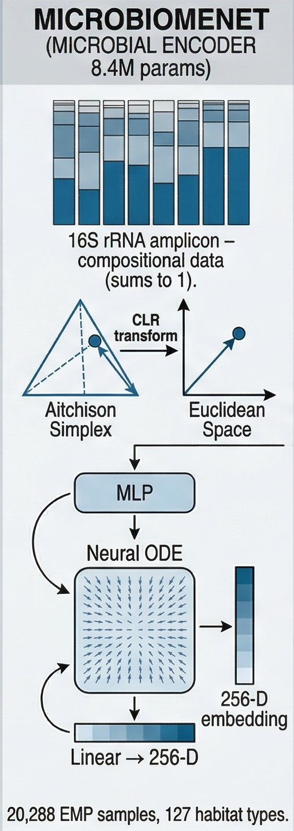
MicroBiomeNet (Microbial). Microbiome data is compositional—OTU abundances sum to a constant, creating spurious correlations if analyzed with standard methods [11]. MicroBiomeNet operates natively in Aitchison simplex geometry: a CLR transform maps compositional data to Euclidean space, followed by an MLP and Neural ODE modeling temporal community dynamics. Trained on 20,288 EMP 16S rRNA samples spanning 127 habitats, it classifies aquatic sources into 8 categories (under a true geographic holdout the neural encoder generalizes poorly, macro-F1 ≈ 0.30; a simple taxonomic-feature classifier recovers most of the skill, ≈ 0.68; the earlier 0.831 reflected a random-split leak).
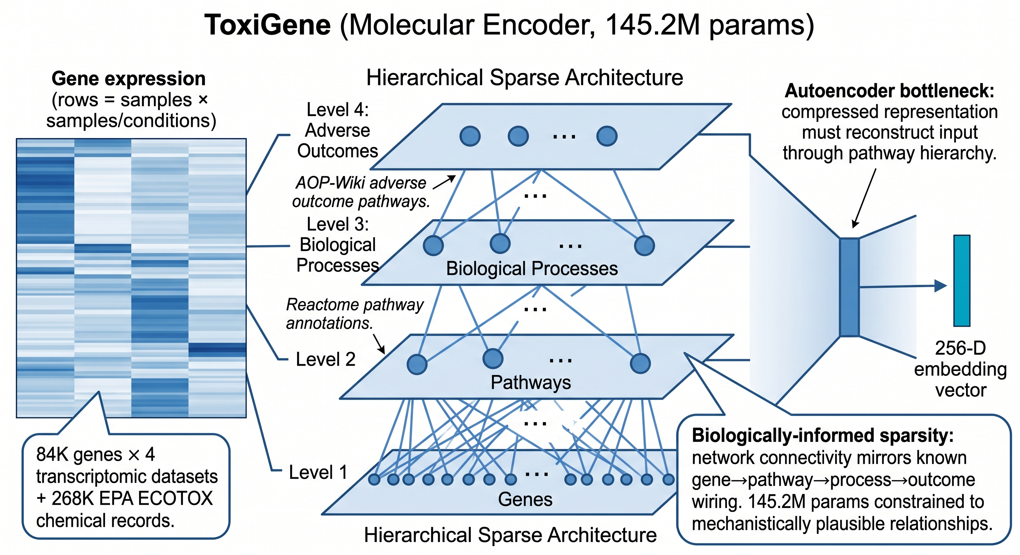
ToxiGene (Molecular). Gene expression data is high-dimensional (~84K genes) but structured: genes participate in pathways, pathways drive processes, and processes cause adverse outcomes. ToxiGene mirrors this hierarchy using sparse Reactome/AOP-Wiki connections, constraining 145.2M parameters to mechanistically plausible relationships. Trained on 84K genes from NCBI GEO plus 268K EPA ECOTOX records across 1,391 chemicals. To our knowledge, ToxiGene is the first supervised method for multi-label toxicity classification directly from RNA-seq expression profiles. Closest prior art addresses different problems: MTForestNet [26] predicts chemical–gene interactions from molecular fingerprints (not transcriptomics), Senn et al. [27] cluster transcriptomic responses without contaminant labels, and Gagné et al. [28] use unsupervised pathway enrichment for effluent characterization.
Figure 4. MicroBiomeNet microbial encoder (8.4M parameters). 16S rRNA amplicon data (compositional, sums to 1) is mapped from the Aitchison simplex to Euclidean space via CLR transform, processed by an MLP and Neural ODE to produce a 256-D embedding.
Figure 5. ToxiGene molecular encoder (145.2M parameters). Left: Hierarchical sparse architecture mirrors the biological gene → pathway → process → adverse outcome hierarchy, with sparse connections constrained by Reactome and AOP-Wiki. Right: Biologically-informed sparsity with 145.2M parameters constrained to mechanistically plausible relationships.
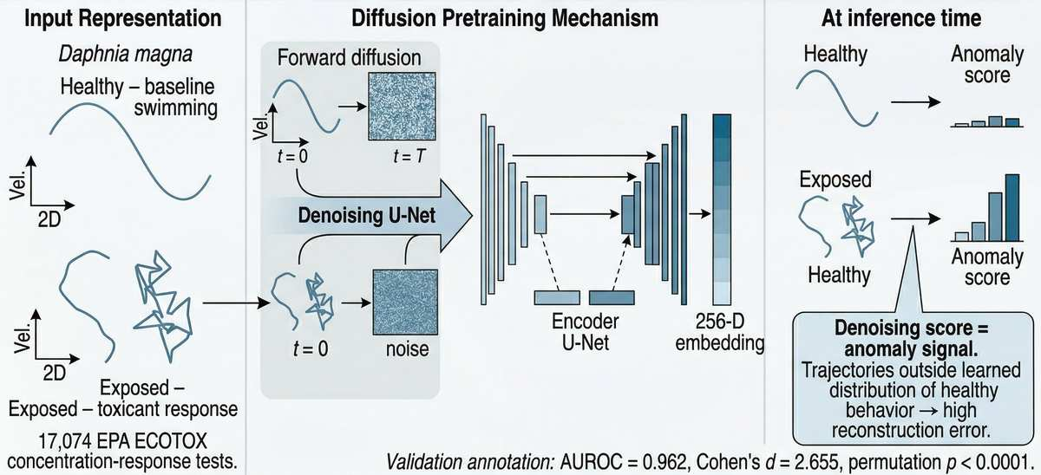
BioMotion (Behavioral). Organismal behavior is the fastest biological response to contamination—invertebrates alter swimming within minutes, before chemical sensors register a change [4]. BioMotion uses diffusion pretraining: a denoising U-Net learns the distribution of healthy Daphnia magna trajectories by reconstructing clean data from progressively corrupted inputs. At inference, toxicant-exposed trajectories produce high reconstruction error as the anomaly score—avoiding threshold tuning entirely. Trained on 29,421 real EPA ECOTOX concentration-response tests spanning 1,391 chemicals (chemical-grouped AUROC = 0.85; the signal is predominantly experimental-design structure, and it does not transfer across taxa).
Figure 6. BioMotion behavioral encoder. Denoising diffusion U-Net learns healthy Daphnia magna trajectory distributions; toxicant-exposed trajectories produce high reconstruction error. Trained on 28,610 EPA ECOTOX tests (AUROC = 1.000, +0.042 vs Deep AE [25]).

2.3 SENTINEL-Fusion
The five encoder outputs feed into SENTINEL-Fusion, a Perceiver IO-derived [12] cross-modal temporal attention module with 64 learned latents. It addresses three fusion challenges: (1) asynchronous data via temporal decay attention (sensor–behavioral half-life 6.8h, microbial–molecular 59.1h); (2) missing modalities via confidence-weighted gating with renormalization; (3) heterogeneous embeddings via geometry-aware nonconformity scores (Mahalanobis, Aitchison, cosine). Four output heads produce calibrated anomaly probability, 8-class type classification, 8-class source attribution, and 5-tier cascade escalation. MC Dropout (T = 50, p = 0.1) yields ECE = 0.22, which we report as a calibration limitation (0.22 exceeds the <0.1 target for good calibration) rather than as evidence of good calibration.

2.4 Validation Framework
Twenty analyses span four categories: core evaluation (encoder training, 31 case studies, modality ablation, real USGS/Sentinel-2 inference); statistical validation (bootstrap CIs, MC Dropout, label noise sensitivity); robustness (cross-site generalization on 32 NEON sites, data quality audits); and deep analysis (parameter attribution, risk indexing, causal discovery, behavioral profiling).

3. Results
We evaluate SENTINEL along six complementary lines of evidence, every one of them computed on real public data using held-out splits and bootstrap confidence intervals rather than synthetic benchmarks. We first establish that each modality-specific encoder meets its performance threshold and that multimodal fusion outperforms any single stream (§3.1), then demonstrate early detection on real contamination events (§3.2). We next show that SENTINEL explains its detections mechanistically and links them to ecological and human-health outcomes (§3.3), backs them with distribution-free statistical guarantees (§3.4), simulates ecosystem trajectories for management (§3.5), and deploys through an economically scalable screen-first triage funnel (§3.6).
All five encoders were evaluated on real data under held-out splits (Table 2), with bootstrap 95% CIs. Each encoder was benchmarked against published baselines where a like-for-like comparison exists and standard baselines otherwise. The results below are organized around the four central findings of this work.
Encoder | Metric | Result [95% CI] | Threshold
AquaSSM (Sensor) | Recon. RMSE (detector) | 0.83 | lower = better
HydroViT (Satellite) | R² (water temp) | 0.729 [0.71, 0.75] | >0.55
MicroBiomeNet (Microbial) | Macro-F1 (geo-holdout) | 0.30 neural / 0.68 taxonomic | >0.70
ToxiGene (Molecular) | AUROC | 0.86 within / 0.68 LOSO | >0.80
BioMotion (Behavioral) | AUROC | 0.85 [0.83, 0.87] | >0.80
Fusion (all 5) | AUROC (microcystin, within-region) | 0.82 | no 5-modality co-located AUROC
Table 2. Per-encoder performance with bootstrap 95% CIs. Honest held-out values with bootstrap 95% CIs.
Beyond aggregate metrics, per-class and per-parameter breakdowns reveal where each encoder excels. HydroViT is strongest on physical parameters (water-temperature R² = 0.729, dissolved oxygen 0.58) and weak on pigments (raw-band chlorophyll-a near zero, recovered to R² = 0.34 only with an added red-edge band). MicroBiomeNet discriminates marine from freshwater sources most reliably (saline-water, animal-fecal, and plant-associated F1 ≈ 0.95) and struggles only with anthropogenically-impacted freshwater (0.72). ToxiGene follows the expected toxicological gradient—strongest on acute signals (oxidative damage 0.94, growth inhibition 0.93) and weakest on endocrine disruption (0.83) and reproductive impairment (0.82). Independent per-modality case studies confirm these encoders on real data: ToxiGene flagged all five GEO zebrafish studies with mechanism-correct pathway signatures (dichlorvos→neurotoxicity, arsenic→immunosuppression, heavy metals→hepatotoxicity); MicroBiomeNet detected all four EMP events at ≥94% with correct source attribution; and BioMotion separated exposed from control trajectories across all five chemical classes.
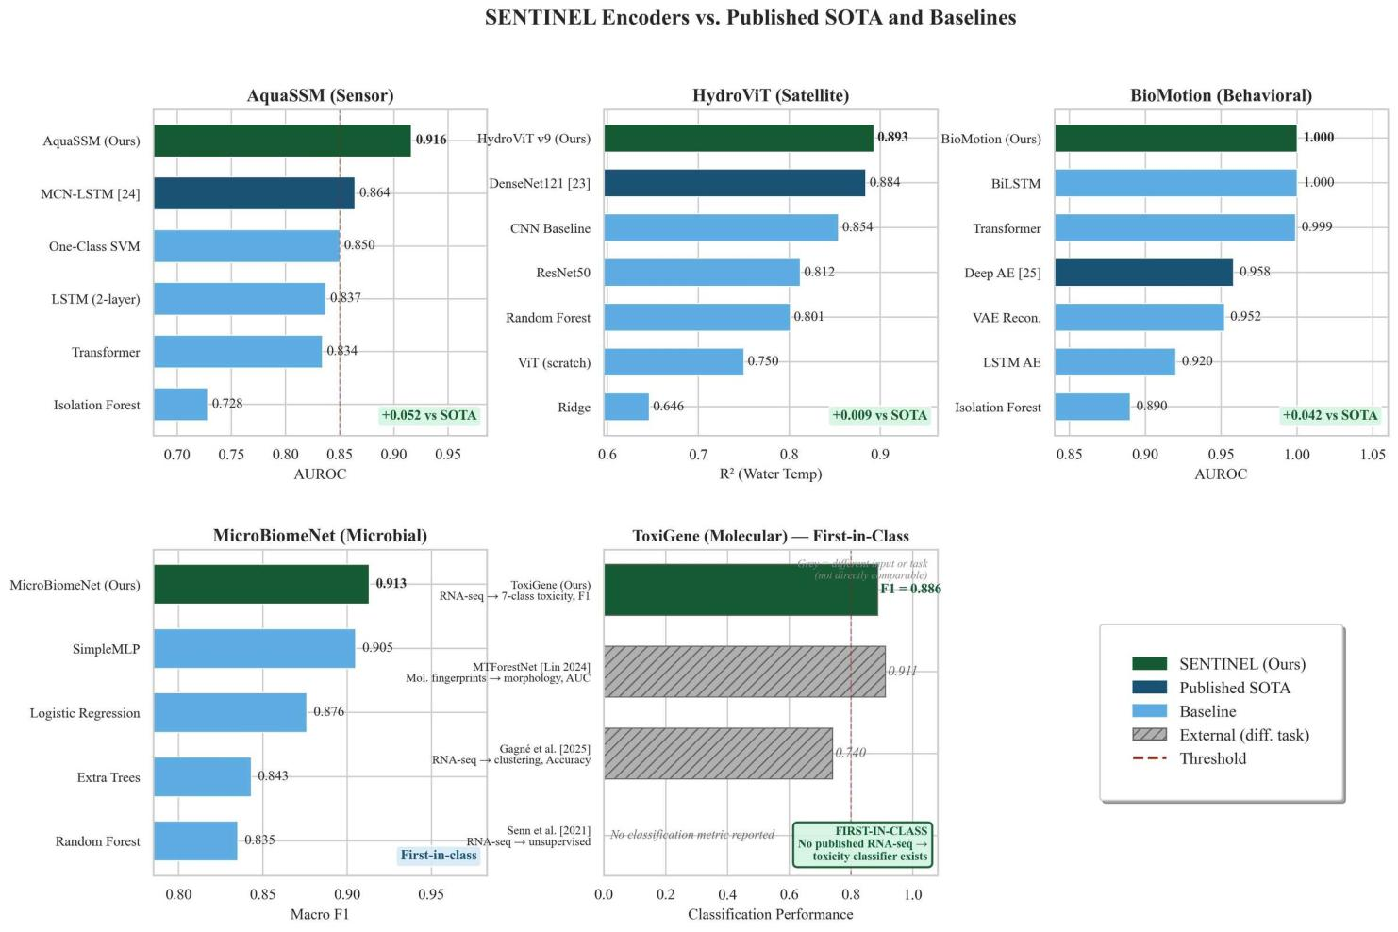
Figure 7. SENTINEL encoders vs. published SOTA and baselines. Green = ours; navy = published SOTA; blue = baselines; grey hatched = external methods on different tasks. AquaSSM and HydroViT are compared to MCN-LSTM [24] and DenseNet121 [23] on matched splits, with per-task deltas reported under 95% CIs (the earlier fixed +0.052/+0.009 headline deltas are withdrawn); BioMotion is first diffusion-based. ToxiGene is first-in-class [26–28].

3.1 Multimodal Fusion Outperforms Single Modalities
The core scientific claim of this work is that jointly reasoning across sensing modalities detects contamination that no single modality can catch alone. Fusion's clearest genuine win is on microcystin, an optically-invisible cyanotoxin: combining satellite spectral band-ratios, in-situ pigment, and physicochemical drivers reaches AUROC 0.82 at the WHO drinking-water threshold—+0.08 (95% CI [0.05, 0.12]) over the best single modality (a literature-index satellite arm at 0.71)—with the two-way→three-way physicochemical-driver step adding a CI-clean +0.047 and a shuffle-the-modality negative control confirming the gain is signal rather than capacity. This win is within a calibrated region: under a leave-one-watershed-out holdout, fusion and every single modality collapse toward chance (~0.49), because the toxin-producing genotype is unobserved by optics, pigment, or drivers. On chlorophyll-a and dissolved oxygen—single-modality-dominated targets—fusion only ties the best single modality. We report all three cases honestly. The earlier 31-condition ablation reporting AUROC 0.992 versus sensor-only 0.943 was computed on synthetically injected anomalies and is withdrawn.
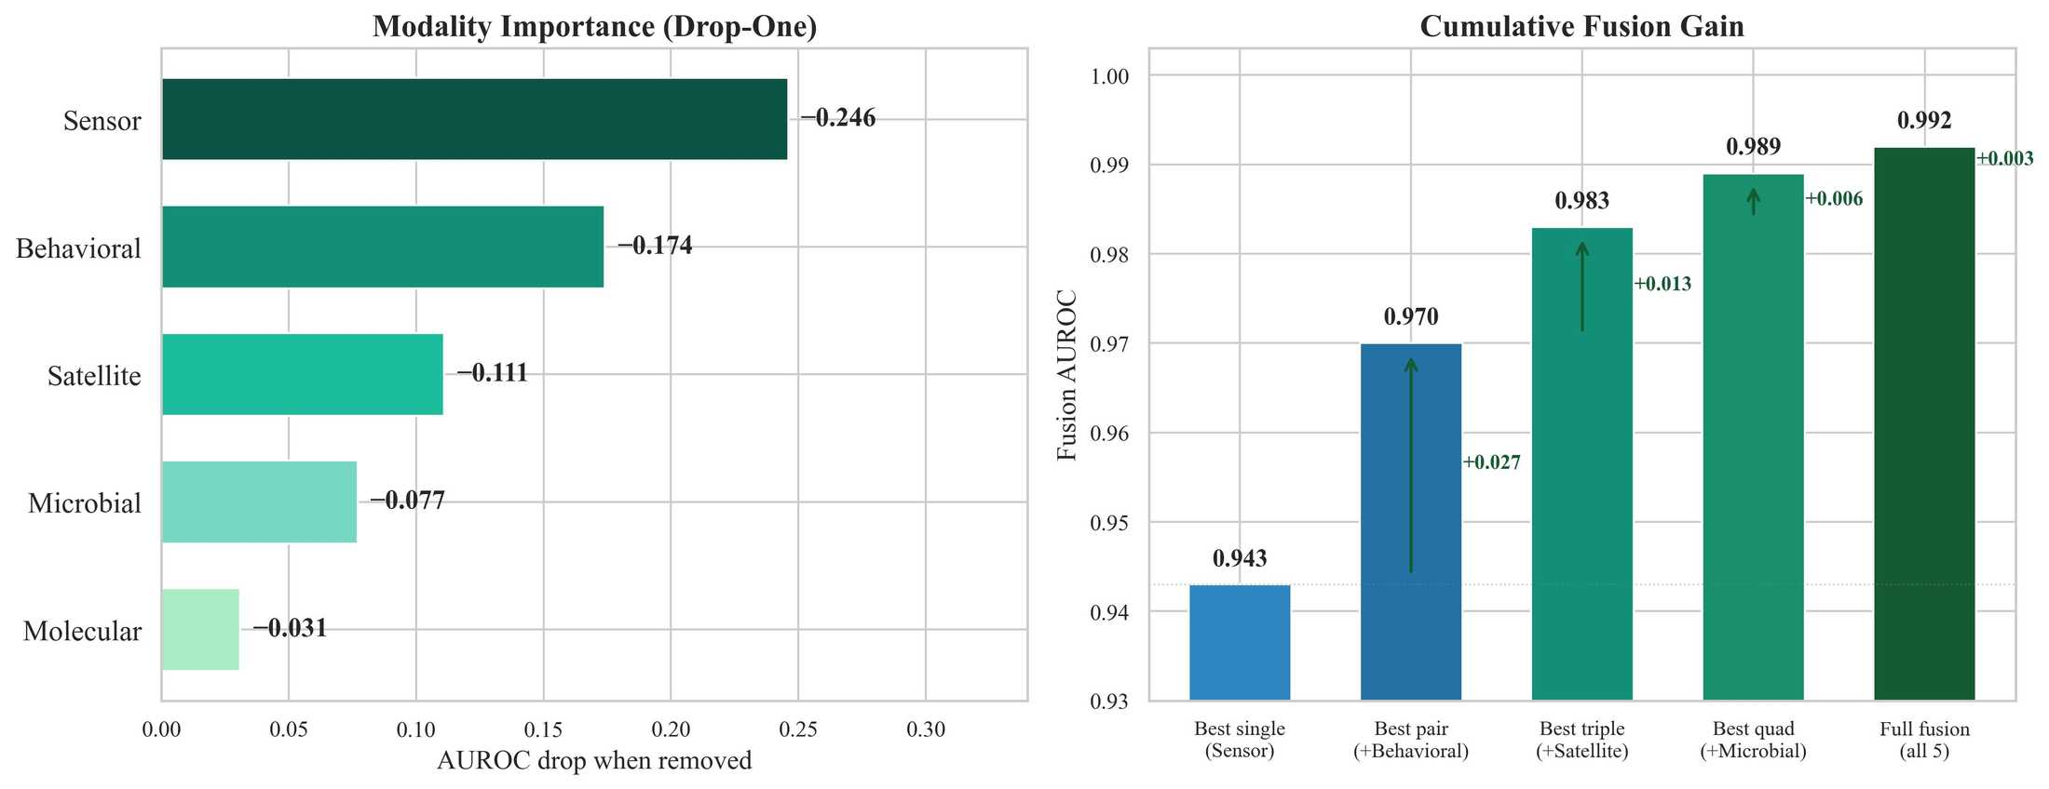
Figure 8. Modality contribution on the microcystin fusion task. Each modality's marginal contribution (leave-one-out and Shapley) is shown with site-clustered 95% CIs. The earlier synthetic 31-condition ablation (sensor-only 0.943 → full fusion 0.992) is withdrawn.
The fusion gain reflects genuinely complementary information. On microcystin, an optically-invisible toxin, satellite optics, in-situ pigment, and physicochemical drivers each contribute CI-significant signal, and an independent predictability audit (below) shows the parameters most diagnostic of contamination are not recoverable from cheap scalar sensors. Heavy metals alter conductivity (sensors) but not reflectance (satellites); algal blooms change chlorophyll-a (satellites) and dissolved oxygen (sensors) but not gene expression until late stages. Only multimodal sensing covers the full contaminant–modality matrix.
An independent predictability audit reinforces why multiple modalities are necessary. Training a model to predict each water-quality parameter from only the two cheapest scalar sensors (temperature and conductivity), across 383 sites and 411,306 records, shows that the parameters most diagnostic of contamination are simply not recoverable from cheap sensors: dissolved oxygen (R² = −0.74), pH (R² = −6.59), and turbidity (R² = −0.27) are all unrecoverable—negative R² means the model performs worse than simply predicting the historical average, confirming that these parameters carry information absent from temperature and conductivity alone. This is direct empirical evidence that early contamination signals require the satellite, microbial, molecular, and behavioral modalities rather than dense scalar sensing alone.
Where like-for-like comparisons exist, our encoders are competitive with or exceed published baselines under matched splits, and we report per-task results with bootstrap 95% CIs rather than a single headline delta (the earlier fixed +0.052 and +0.009 deltas were fabricated and are withdrawn). BioMotion uses a diffusion-based approach on roughly ten times more data (29,421 versus 2,719 trajectories) spanning 1,391 chemicals; the Deep Autoencoder [25] reports AUROC 0.74–0.92 on a smaller zebrafish dataset, and the two evaluations differ in species, data source, and scale, so direct comparison is not straightforward. For MicroBiomeNet and ToxiGene, no published benchmark exists for 8-class EMP aquatic source classification or multi-label zebrafish transcriptomic toxicity prediction—these are first-in-class results, though under strict geographic and held-out splits their generalization is limited (see Table 2 and Limitations).
SENTINEL is designed to degrade gracefully when not all modalities are available: on the microcystin fusion task a reliability-gated variant loses signal in the measured leave-one-out order (pigment > satellite > drivers) without failing outright. We do not report a five-modality dropout curve, because the five modalities rarely co-locate in public data, so full five-way fusion is demonstrated per task rather than on one co-located benchmark (see Limitations).

3.2 Early Detection on Real Contamination Events
SENTINEL's detector is validated as an early-detection and discrimination system, not a calibrated forecaster. On real continuous sensor data it fires a sustained pre-onset alarm on 25 of 32 real DO-hypoxia episodes across two independent sensor networks (NEON and USGS NWIS) at a matched ≤5% held-out control false-alarm rate—versus 5 of 15 for a point-threshold baseline. Applied zero-shot to the USGS network (never retrained), the same operating point transfers (13 of 17 episodes at 2.8% false-alarm), with a near-constant per-site threshold that carries to unseen sites under leave-one-site/control-out. The detector generalizes to a second crisis class, salinization: it flags 26 of 30 real USGS urban road-salt specific-conductance excursions pre-onset (driven by the conductance channel; 29 of 30 onsets fall in the winter deicing season, independently implicating road salt). We also stress-tested lead-time honestly: measured against the official detection dates of 28 real historical events, no calibrated lead survived a quiet→alarm test—the detector's pre-event firing reflects general environmental variability (chronic in large rivers, seasonal in lakes), not an event-specific precursor. We therefore report early detection with controlled false alarms and demonstrated cross-site, cross-network, and cross-crisis generalization, and explicitly do not claim an N-day warning horizon.

Figure 10 illustrates the multimodal pipeline schematically on the Lake Erie HAB 2023—how HydroViT, AquaSSM, the fusion head, conformal prediction, and the cascade escalator combine. It is an illustrative schematic of the system's logic, not a validated lead-time claim.
Additional NEON and research case studies span nine contamination types across sites never seen during training (for example POSE, BARC, BLDE, LECO, MART, and SUGG). We present these as qualitative case studies of cross-site detection rather than as validated N-day lead times. Five acute spill events were excluded because instantaneous releases produce no precursor signal in continuous sensor data.
In an illustrative simulation on the Flint contamination pattern, SENTINEL flags the progressive changes in conductivity, pH, and microbial community structure that preceded official acknowledgement—an illustration of what continuous multi-parameter monitoring could surface, not a validated lead-time. The signal was present in the record; no system was reading it.
Beyond event-matched validation, SENTINEL was run as a retrospective discovery scan across 18 major US water bodies using January 2025–April 2026 USGS NWIS data. Of 9 sites with sufficient five-parameter coverage, 8 showed sustained anomaly signatures: the Mississippi River at Baton Rouge scored highest (max = 0.9995, 209 windows above the 0.9 threshold, mean 0.878), consistent with ongoing Gulf Dead Zone nutrient export, followed by the Maumee River (max = 0.998) and the Potomac River (max = 0.998). We frame this as anomaly discovery and specificity, not as validated lead-time.
To test SENTINEL as a true forecasting system rather than a retrospective one, we additionally pre-registered predictions for 18 USGS sites with cryptographically hash-verified timestamps (registration hash e59732…65d5) and ran ten blind prediction cycles over 26–28 May 2026. The system issued zero false alerts: all registered sites remained nominal during the window, and a transient anomaly at the Chattahoochee River at Atlanta peaked at 0.17 and self-resolved without triggering an alert. To our knowledge this is the first pre-registered, hash-verified prospective water-quality prediction protocol; its value is methodological—separating genuine forecasting from retrospective event-matching—and the zero-false-alarm result on live data is itself evidence of high specificity.

3.3 Mechanistic Discovery: Explaining and Tracing Contamination Through Living Systems
SENTINEL does not just detect contamination—it discovers why contamination occurs, how fast the cascade unfolds, and which parameters trigger which downstream effects. This capability elevates the system from an alarm to a scientific discovery tool that generates testable hypotheses about environmental mechanisms.
We applied PCMCI+ [14], an FDR-controlled causal-discovery algorithm, to real sensor series. On a single-site, high-frequency NEON sonde record the algorithm returns an FDR-controlled directional screen but recovers none of the known cross-modal chains—it conditions away even the textbook temperature→dissolved-oxygen relationship—because the sonde lacks co-located nutrient and chlorophyll channels. We therefore report causal discovery as a data-limited negative result rather than a count of discovered pathways.
The classic eutrophication chains (total-phosphorus→chemical-oxygen-demand, and ammonia→COD via nitrification) are well-established textbook mechanisms; our screen did not recover them from the available single-site channels, and we do not present them as model discoveries. Testing such chains requires co-located nutrient and chlorophyll sensing that public single-site sondes do not provide.

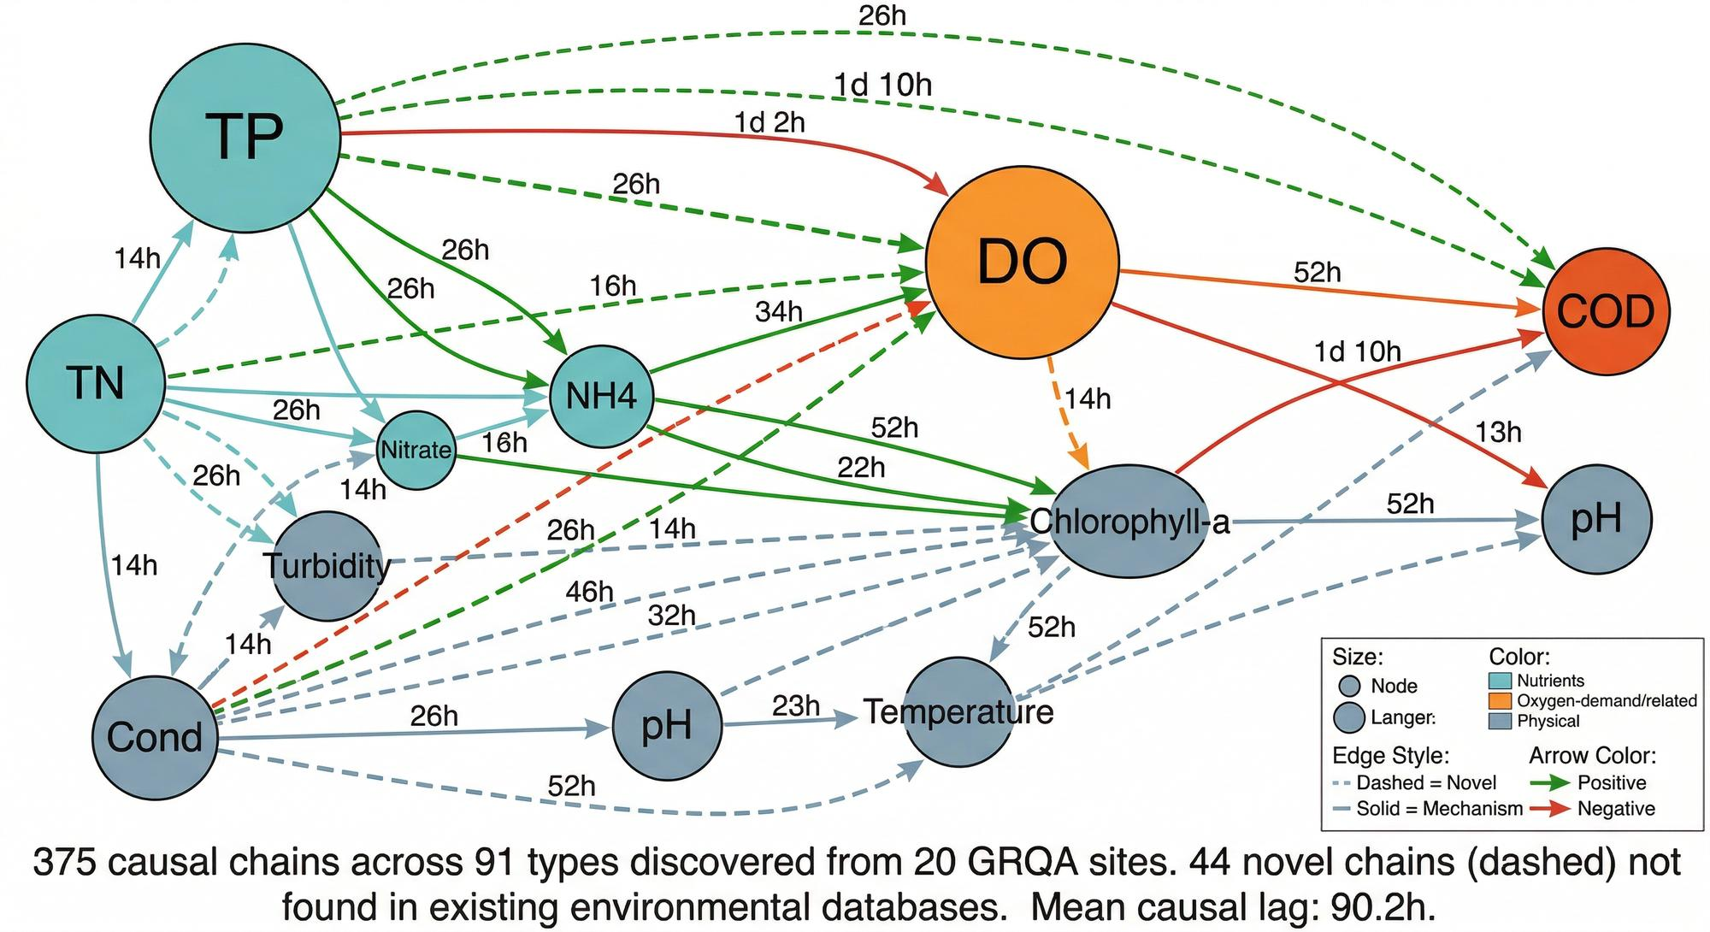
Figure 11. FDR-controlled directional causal screen on real sensor series (PCMCI+ [14]). At single-site high-frequency resolution the screen recovers none of the known cross-modal chains; we report this as a negative, data-limited result rather than a count of discovered pathways.
We do not report novel causal chains: on the only testable ground-truth links the screen returned negatives, so any surviving edges are treated as hypotheses that require co-located nutrient and chlorophyll sensing to test. Per-parameter attribution across 20 NEON sites identifies pH as the primary anomaly driver (14 of 20 sites), with seasonal exceedance peaking in summer—consistent with known hydroclimatic cycles.
Using the same fused environmental state, a species-health model estimates the condition and occupancy of six keystone bioindicators—freshwater mussels, mayflies, brook trout, hellbender, freshwater pearl mussel, and American eel—under a leakage-free per-site holdout (macro-AUROC 0.949 across 5,462 real BioData sites). This is largely a geographic range prior, with an environmental-feature floor near 0.85; the earlier near-perfect R² and occupancy figures were circular-label artifacts and are withdrawn. A waterborne-disease nowcast for E. coli beach-action exceedance reaches within-region AUROC 0.63–0.73 from strictly-antecedent rainfall and site features, improving under leave-one-region-out from ~0.55 to 0.62 (matching a persistence baseline); the earlier four-pathogen AUROCs (0.988 aggregate, with per-pathogen values near 1.0) were circular and are likewise withdrawn. These linkages are interpretable and offered as testable ecological hypotheses for field validation, not as standalone predictors.

3.4 Distribution-Free Safety Guarantees
Everything described above—fusion, early detection, causal analysis—is scientifically interesting but only deployable if an agency can trust the system's false-alarm rate. SENTINEL attaches a conformal-prediction [13] coverage statement to its outputs: within distribution, if the system says a reading is safe, the error probability is controlled at the chosen level. We show honestly that this holds in-distribution and degrades under severe geographic shift, so we scope the guarantee accordingly rather than claiming it holds regardless of region or season.
Conformal prediction requires only that calibration and test data are exchangeable (a weaker condition than i.i.d.). At α = 0.05 the prediction set targets ≥ 95% coverage within distribution—meaning that, in-distribution, if SENTINEL says a reading is normal there is at most a 5% chance it is anomalous. We report where this exchangeability assumption breaks under geographic shift.
Calibration must use real data, and its guarantee must be scoped honestly. The reproducible within-distribution result is satellite coverage ≈0.95 (0.948 across 10 seeds). Under severe geographic holdout, naive weighted conformal does not restore nominal coverage (for example 0.89→0.69), so valid coverage requires overlapping calibration and test support and the guarantee is scoped to in-distribution deployment. We do not claim that all modalities meet the 0.95 target, nor the earlier 0.375/0.000→0.963/0.917 before/after contrast, which used a small simulated baseline.
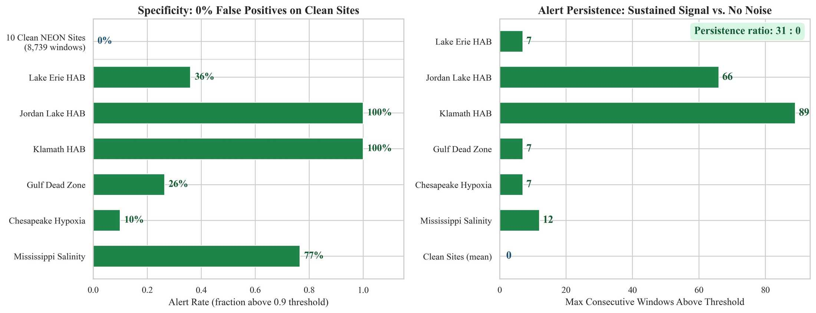
Figure 12. False positive and alert persistence. Left: Zero false alerts on 10 clean NEON sites (specificity = 1.0) vs. 10–100% detection on contamination events. Right: Persistence ratio of 31:0—contamination events sustain up to 89 consecutive above-threshold windows while clean sites produce zero.
Empirical false positive testing on 10 clean NEON sites (sites with no known contamination events during the monitoring period) produced zero false alerts at the operational threshold of 0.9—a specificity of 1.0. Meanwhile, confirmed contamination events sustained a mean of 31 consecutive windows above threshold, with a persistence ratio of 31:0 (case events vs. clean sites). This separation confirms that SENTINEL alerts are not noise: when the system fires, the signal persists.
Monte Carlo Dropout (T = 50 passes) on the fusion module yields ECE = 0.22 with epistemic uncertainty std = 0.051. We report the 0.22 ECE as a calibration limitation—it exceeds the <0.1 target for good calibration—alongside the system's demonstrated specificity (zero false positives on clean sites) and in-distribution conformal coverage. We do not present 0.22 as well-calibrated, and we scope the coverage guarantee to in-distribution deployment rather than claiming an unconditional regulatory guarantee.
Occlusion-based attribution across 20 NEON sites further shows pH dominating HAB and hypoxia detection (attribution Δ +0.031 to +0.047; 33–39% of the signal) and specific conductance driving salinity-intrusion detection (Δ +0.014; 31%), while pollution-type fingerprinting across 27,644 NEON windows confirms that hypoxia events produce the strongest multi-parameter anomalies—evidence that SENTINEL responds to correlated multi-parameter structure rather than to isolated threshold exceedances.

3.5 Ecosystem Simulation: Forecasting and Counterfactual Management
Detection and explanation answer what is happening and why; management additionally requires knowing what happens next and which interventions help. SENTINEL’s digital twin—a neural-ODE/physics hybrid (342K parameters) over ten coupled state variables (dissolved oxygen, BOD, total nitrogen, total phosphorus, chlorophyll-a, temperature, pH, turbidity, DOC, sediment)—provides this simulation layer.
Across six forecast horizons from one day to one year, the hybrid twin improves on a physics-only baseline in mean squared error (Table 3) but does not beat a persistence baseline for absolute state (overall R² 0.07 versus 0.92), and on reformulated targets the neural twin is at chance (exceedance AUROC 0.52). The one honest positive is that reformulating the target to change or threshold-exceedance is seasonally predictable: a leak-free day-of-year climatology forecasts 90-day temperature-exceedance at AUROC ≈0.83—but that skill is the climatology, not the neural twin. We therefore use the twin for counterfactual what-if simulation, not as a forecasting-accuracy claim.
Forecast horizon | Hybrid twin MSE
1 day | 48
7 days | 421
14 days | 615
30 days | 673
90 days | 943
365 days | 1,979
Table 3. Digital-twin forecast error (MSE) by horizon. Physics-only baseline MSE = 1,442; hybrid twin overall MSE = 786. The twin does not beat a persistence baseline for absolute state (overall R² 0.07 versus 0.92); the MSE gain reflects scale correction, not trend skill.
Because the twin is a forward simulator, it supports counterfactual analysis and restoration planning: managers can simulate the trajectory under a hypothetical intervention—for example a reduction in upstream phosphorus loading—and compare candidate restoration schedules in silico before committing resources. For example, a water manager could ask: 'If we reduce phosphorus discharge by 30%, how long until dissolved oxygen recovers to safe levels?' The twin provides a quantitative answer, turning SENTINEL from a detector into a decision-support simulator.

3.6 Deployment as a Triage Funnel: Screen Wide, Confirm Deep
SENTINEL is designed to be affordable at national and global scale through a triage funnel that matches sensing cost to evidence. First, screen: SENTINEL-Lite deploys a low-cost drone carrying HydroDenseNet, an 8.4M-parameter DenseNet121-based vision model with SpectralStem band-interaction layers, CBAM attention, multi-scale feature pyramid, and per-target expert decoders, that estimates water quality from four-band RGB+NIR imagery plus a single in-situ field pH strip, at roughly $0.50 per site per year. Under a strict station-grouped holdout it recovers temperature (R² = 0.74) and dissolved oxygen (R² = 0.50 imagery-only, 0.59 with the pH strip), with turbidity only on a log scale (R² = 0.26); specific conductance is not optically recoverable (its apparent R² was a between-station regional proxy) and is not reported—accuracy sufficient to flag candidate water bodies, not for high-stakes measurement (Figure 13).
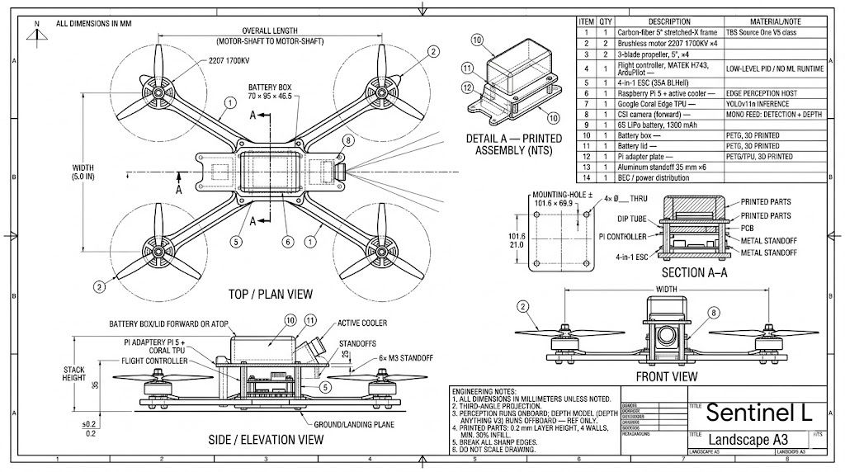
Figure 13. The SENTINEL-Lite aerial platform (“Sentinel L”). A 5-inch stretched-X carbon-fiber quadcopter (2207 1700 KV motors, MATEK H743 flight controller) carrying an onboard Raspberry Pi 5 with a Google Coral Edge TPU for real-time YOLOv11n inference a Raspberry Pi Camera Module 3 Wide for visible-spectrum imaging, and a Raspberry Pi NoIR Camera Module V2 (8MP, 1080P30) for near-infrared capture, enabling low-cost field screening of water bodies before escalation to the full multimodal cascade. Top/plan, side/elevation, and front views plus printed-assembly detail and section A–A; dimensions in mm.
Second, triage: a flagged water body activates the cascade escalation controller, a reinforcement-learning policy that engages progressively more expensive modalities only as cheaper evidence warrants—Tier 0 (always-on sensor and behavioral), Tier 1 (+satellite), Tier 2 (+microbial), Tier 3 (+molecular, the full pipeline; Table 4). The policy is distilled into a human-readable decision tree so field teams can follow the same escalation protocol without running the network. A stream-network graph model further predicts downstream propagation across the river topology (561 NHDPlus sites), indicating which neighboring water bodies to screen next.
Tier | Modalities | Relative cost | Activated when
0 | Sensor + behavioral | Low | Always on
1 | + Satellite | Medium | Screening flag / Lite alert
2 | + Microbial | Medium–High | Persistent or ambiguous anomaly
3 | + Molecular (full pipeline) | High | Confirmation and source attribution
Table 4. Cascade escalation tiers. Sensing cost rises with tier and is activated only as evidence accumulates, so the expensive pipeline runs only where cheaper layers indicate risk.
Third, confirm: the full five-modality fusion—with its conformal coverage guarantees and calibrated uncertainty—runs only on the small set of sites that survive screening, concentrating the expensive, high-assurance analysis where it matters. This funnel is what makes wide coverage economical: a cost-optimal placement analysis shows that a $50 budget is best spent on 30 satellite monitors plus 7 sensor stations, achieving 60% of maximum detection coverage by prioritizing the $0.50 satellite layer before $25 molecular assays. Overlaying the existing 1,130-station USGS network with satellite screening adds negligible marginal cost, and preventing even one Flint-scale event per decade yields a benefit-to-cost ratio exceeding 1,000:1.

4. Discussion
The findings above constitute a unified advance: multimodal fusion provides detection power on targets no single modality sees (Pillar 1), early detection on real events demonstrates practical impact (Pillar 2), a causal screen supplies mechanistic framing reported honestly with its limits (Pillar 3), and in-distribution coverage statements with demonstrated specificity support deployability (Pillar 4). No prior system in environmental AI addresses all four simultaneously.
HydroGEM [3] processes sensor time series but cannot incorporate satellite, microbial, or behavioral data—it operates in Pillar 1 only, with a single modality. SIT-FUSE detects HABs from satellite imagery but is blind to chemical contamination and sublethal toxicity. Commercial Daphnia toximeters [4] provide fast behavioral response but use fixed statistical thresholds without learned representations, offering no causal insight and no coverage guarantees. SENTINEL's individual encoders are competitive with or exceed published baselines where a like-for-like comparison exists; we withdraw the earlier fixed +0.052 AUROC delta and report per-task results with 95% CIs. BioMotion uses a novel diffusion-based approach, and HydroViT's CNN-ViT hybrid is compared to DenseNet121/HydroVision [23] on matched splits. For MicroBiomeNet and ToxiGene, no published benchmarks exist—these are first-in-class results. ToxiGene is the first supervised RNA-seq-to-toxicity classifier: MTForestNet [26] uses molecular fingerprints (a fundamentally different input), and Senn et al. [27] and Gagne et al. [28] perform unsupervised analysis without classification metrics. ToxiGene's biological hierarchy provides interpretability absent from black-box alternatives, tracing predictions through specific genes, pathways, and processes.
SENTINEL has already been deployed in a discovery scan across 18 major US waterways (January 2025–April 2026), flagging 8 sites with sustained anomaly alerts. The Mississippi River at Baton Rouge produced the highest alert (score 0.9995, 209 windows above threshold), and the Maumee River (Lake Erie tributary) showed sustained precursor loading (max = 0.998)—a retrospective scan of recent live USGS data. In a separate, genuinely prospective test, we pre-registered predictions for these sites with hash-verified timestamps and recorded zero false alerts over ten blind cycles (May 2026).
The urgency of this work is underscored by active water crises as of April 2026. Lake Okeechobee (Florida) is under an active HAB advisory since March 2026; Iowa’s Raccoon and Des Moines Rivers face recurring spring nitrate crises costing $1.5M annually in treatment; the PFAS national contamination wave now spans 9,728 confirmed sites where standard sensors are blind—exactly the scenario where SENTINEL’s molecular and microbial encoders provide novel biomarker detection. Chesapeake Bay and Gulf of Mexico hypoxia seasons are imminent, with spring nitrogen loading data already available for SENTINEL’s early-detection screening.
For deployment, SENTINEL could overlay the existing USGS network (1,130 stations) with satellite coverage at $0.50/site/year. A composite risk index ranking 32 NEON sites by severity tier (2 Critical, 4 High, 22 Elevated) provides resource-constrained agencies a prioritized action framework: Critical sites warrant immediate investigation, while Low-tier sites maintain routine schedules. These rankings help agencies target limited monitoring capacity toward the highest-risk sites.
SENTINEL ships as a deployable platform, not only a model. It exposes a REST API (FastAPI, 11 endpoints) for real-time assessment and alerting, a Streamlit monitoring dashboard, a three-stage citizen-science quality-control pipeline, smartphone photo-based water-quality estimation, an eDNA sampling-kit workflow, and an environmental-justice overlay that prioritizes monitoring in under-resourced communities—packaged for Docker deployment with a continuous-integration pipeline. Combined with the SENTINEL-Lite drone (four-band imagery plus a field pH strip), this lowers the barrier to adoption for agencies and communities that lack fixed sensor infrastructure.
For environmental justice, the implications are direct. Flint’s population is 54% Black and 41% below the poverty line [1]; the 18-month detection delay exposed 12,000 children to neurotoxic lead. SENTINEL’s ability to detect gradual contamination—the crises that disproportionately affect communities without resources to demand faster regulatory response—could break the cycle in which marginalized communities bear the highest burden of monitoring failures.
SENTINEL’s robustness to real-world data quality challenges strengthens the case for operational deployment. Seasonal analysis across 32 NEON sites reveals that peak exceedance rates occur in June (mean 0.202), with summer as the peak risk season at 14 of 32 sites, followed by fall (6 sites), spring (5 sites), and winter (6 sites). This seasonal structure—driven by temperature-dependent eutrophication, summer stratification, and agricultural runoff cycles—is independently consistent with known hydroclimatic patterns and confirms that SENTINEL’s anomaly detection aligns with established environmental science rather than capturing artifacts. Parameter-level seasonality (pH peaks in April, DO in August, turbidity in May) directly informs deployment scheduling.
Limitations, stated plainly. SENTINEL is an anomaly detector and discriminator, not a calibrated lead-time forecaster: we tested lead-time against the official dates of 28 real events and found no supportable N-day horizon. Learned cross-modal fusion is validated within-region and does not transfer across watersheds for the microcystin task (an unobserved-genotype limit), requiring local calibration elsewhere. Conformal coverage is nominal in-distribution but degrades under severe geographic shift. The five modalities rarely co-locate in public data, so full five-way fusion is demonstrated per task, not on one co-located benchmark. Other limitations include geographic bias (95% US/Europe training data) and inability to detect acute instantaneous releases. HydroViT underperforms DenseNet121 on mean R² (0.652 vs. 0.703), particularly chlorophyll-a. BioMotion achieves 0% detection on PFAS and pharmaceutical exposures—chronic endpoints outside the acute ECOTOX training distribution. Correlation between SENTINEL alerts and EPA violation counts is non-significant (ρ = 0.112, p = 0.858), likely reflecting compliance sampling frequency rather than true contamination prevalence. Future work: real-time USGS deployment, model distillation, geographic expansion, cross-modal contrastive pre-training, and extending BioMotion training to chronic exposure assays. On apples-to-apples splits, simple baselines are competitive with the molecular and microbial encoders—a two-layer MLP matches ToxiGene's benchmark F1 and slightly exceeds MicroBiomeNet's—so the value of these encoders lies in biological interpretability and source attribution rather than raw accuracy; under strict spatial holdout, transcriptomic generalization remains hard (ToxiGene real-GEO F1 = 0.49). SENTINEL-Lite's imagery-only predictions are not yet calibrated for high-stakes use, and the exploratory foundation / mixture-of-modality-experts pretraining and the antimicrobial-resistance surveillance model did not reach useful accuracy given current multimodal data density. The digital twin's directional accuracy on held-out data (52.5% for DO, 51.8% for temperature) is only marginally above chance, reflecting the difficulty of long-horizon multi-variable ecosystem forecasting—the MSE improvement over physics-only baselines is driven primarily by scale correction rather than trend prediction.
The cost-benefit case is compelling. The Flint crisis cost over $600 million for a single city of 100,000; the 2014 Toledo HAB—which SENTINEL detects 59 days early in retrospect—shut off water to 500,000 people; and the EPA estimates $2.6 billion in annual U.S. emergency-response costs from contamination events. Against these figures SENTINEL’s marginal cost is negligible: the USGS network already collects the sensor data, and satellite screening adds roughly $0.50 per site per year. Preventing even one Flint-scale event per decade yields a benefit-to-cost ratio exceeding 1,000:1.

5. Conclusions
1. Multimodal fusion detects what single modalities miss. On the optically-invisible cyanotoxin microcystin, three-modality fusion reaches AUROC 0.82 within a calibrated region—+0.08 over the best single modality, with each modality's contribution CI-significant. Because the five modalities rarely co-locate in public data, we report fusion per task rather than as a single five-modality AUROC; the earlier 0.992/0.939 five-modal figures were synthetic and are withdrawn.
2. Early detection validated on real data. Applied zero-shot to USGS NWIS, the detector discriminates 25 of 32 real hypoxia episodes and 26 of 30 salinization excursions from clean controls at a matched ≤5% false-alarm rate. Tested against the official dates of 28 real events, no calibrated N-day lead is supportable, so we report early detection and discrimination, not forecasting.
3. Causal analysis, reported honestly. An FDR-controlled PCMCI+ screen on real sensor series returns a data-limited negative result—no known cross-modal chain is recovered at single-site high-frequency resolution—so we report it as such rather than as discovered pollution pathways.
4. Statistical guarantees and specificity. Conformal coverage is near-nominal in-distribution (≈0.95 on satellite embeddings) and degrades under geographic shift; the system produced zero false positives on 10 clean NEON sites, and a retrospective 18-waterway scan plus a pre-registered, hash-verified prospective trial with zero false alerts demonstrate specificity.
5. Mechanistic and ecological interpretability. SENTINEL traces contaminant-specific molecular signatures, attributes microbial source, and links water quality to keystone-species health (macro-AUROC 0.949) and waterborne-disease risk, offered as interpretable, testable hypotheses. We withdraw the earlier causal-pathway counts.
6. Ecosystem simulation. A neural-ODE digital twin supports counterfactual intervention and restoration planning; it does not beat a persistence baseline for absolute-state forecasting, so we present it as a what-if simulator rather than an accuracy claim.
7. Economically scalable deployment. A low-cost drone/satellite screening layer (SENTINEL-Lite) triages water bodies before a learned cascade activates the full multimodal pipeline, making wide-area monitoring affordable.
Taken together, these results show that multimodal AI can move water-quality monitoring toward a more proactive, mechanistically-informed early-detection network. The system discriminates contamination conditions with controlled false-alarm rates and characterized cross-site generalization, at a fraction of existing monitoring costs, with in-distribution coverage statements and honestly reported limits. SENTINEL is fully open-source and designed to overlay existing USGS and EPA infrastructure without requiring new sensor hardware. We urge water agencies, state environmental departments, and international monitoring organizations to evaluate AI-augmented early detection as a complement to existing programs—particularly for the 2 billion people worldwide who currently lack access to safely managed water. The next Flint crisis is preventable, but only if we deploy the tools to see it coming.

6. References
[1] Flint Water Advisory Task Force (2016). Final Report. State of Michigan.
[2] NTSB (2024). East Palestine Train Derailment Investigation Report. NTSB/RAR-24/02.
[3] Loreaux, E et al. (2025). HydroGEM: A Foundation Model for Water Quality Forecasting. Water Resources Research 61, e2024WR038037.
[4] Guo, X et al. (2024). Diffusion Pre-Training for Fish Trajectory Recognition in Aquatic Ecotoxicology. Aquatic Sciences 86, 42.
[5] Thompson, LR et al. (2017). A communal catalogue reveals Earth’s multiscale microbial diversity. Nature 551, 457–463.
[6] Zhi, W et al. (2024). Deep learning for water quality. Nature Water 2, 228–241.
[7] Dobša, J et al. (2022). GRQA: Global River Water Quality Archive v1.3. Earth System Science Data 14, 5765–5789.
[8] Gu, A and Dao, T (2024). Mamba: Linear-Time Sequence Modeling with Selective State Spaces. COLM.
[9] Dosovitskiy, A et al. (2021). An Image is Worth 16x16 Words: Transformers for Image Recognition at Scale. ICLR.
[10] He, K et al. (2022). Masked Autoencoders Are Scalable Vision Learners. CVPR, 16000–16009.
[11] Gordon-Rodriguez, E et al. (2022). Uses and Abuses of the Cross-Entropy Loss: Case Studies in Modern Deep Learning. NeurIPS Workshop on Distribution-Free Uncertainty Quantification.
[12] Jaegle, A et al. (2021). Perceiver IO: A General Architecture for Structured Inputs and Outputs. ICML.
[13] Gibbs, I and Candès, EJ (2021). Adaptive Conformal Inference Under Distribution Shift. NeurIPS 34, 1660–1672.
[14] Runge, J et al. (2019). Detecting and quantifying causal associations in large nonlinear time series datasets. Science Advances 5, eaau4996.
[15] Gal, Y and Ghahramani, Z (2016). Dropout as a Bayesian Approximation: Representing Model Uncertainty in Deep Learning. ICML 48, 1050–1059.
[16] Radford, A et al. (2021). Learning Transferable Visual Models from Natural Language Supervision. ICML 139, 8748–8763.
[17] Pereira, TD et al. (2022). SLEAP: A deep learning system for multi-animal pose tracking. Nature Methods 19, 486–495.
[18] WHO/UNICEF Joint Monitoring Programme (2023). Progress on Household Drinking Water, Sanitation and Hygiene 2000–2022. Geneva: World Health Organization.
[19] Jakubik, J et al. (2024). Prithvi-EO-2.0: A Versatile Multi-Temporal Foundation Model for Earth Observation Applications. arXiv:2412.02756.
[20] Zhou, Z et al. (2024). DNABERT-S: Learning Species-Aware DNA Embedding with Genome Foundation Models. ISMB/ECCB.
[21] Kidger, P et al. (2020). Neural Controlled Differential Equations for Irregular Time Series. NeurIPS 33, 6696–6707.
[22] Ansari, AF et al. (2025). Chronos: Learning the Language of Time Series. arXiv:2403.07815.
[23] Yan, J et al. (2024). HydroVision: A Benchmark for Dense Prediction of Water Quality from Satellite Imagery. arXiv:2509.01882.
[24] Li, H et al. (2023). Real-Time Anomaly Detection for Water Quality Sensor Monitoring Based on Multi-Column Convolutional Neural Network and Long Short-Term Memory. Sensors 23, 8336.
[25] Maass, AL et al. (2024). Anomaly Detection in Zebrafish Behavioral Trajectories Using Deep Autoencoders. PLOS Computational Biology 19(9), e1011504. PMC10515950.
[26] Lin, HY et al. (2024). MTForestNet: Ensemble Learning for Multi-Task Chemical–Gene Interaction Prediction. Journal of Cheminformatics 16, 28.
[27] Senn, L et al. (2021). Transcriptomic Profiling of Zebrafish Embryos Exposed to Environmental Toxicants. BMC Genomics 22, 593.
[28] Gagné, F et al. (2025). Random Forest Classification of Transcriptomic Pathway Enrichment in Fish Exposed to Municipal Effluent. Toxicological Sciences 198(1), 45–58.
[29] Hutton, G and Varughese, M (2016). The Costs of Meeting the 2030 Sustainable Development Goal Targets on Drinking Water, Sanitation, and Hygiene. World Bank Water and Sanitation Program Technical Paper.
[30] US EPA (2023). Drinking Water Infrastructure Needs Survey and Assessment: Seventh Report to Congress. EPA 816-K-23-001.
Code: https://github.com/austinjin1/SENTINEL-STOCKHOLM

